**ASSESSMENT 04**

**NAME : NAVEETH KHAN J**

**DATE : 01 – 09 – 2024**

**Problem Statement:**

1. Write a C program to input marks of five subjects . Calculate percentage and grade according to following:  
   Percentage >= 90% : Grade A  
   Percentage >= 80% : Grade B  
   Percentage >= 70% : Grade C  
   Percentage >= 60% : Grade D  
   Percentage >= 40% : Grade E  
   Percentage < 40% : Grade F

**Solution:**

**Explanation :**

1. Get Five Marks from the User
2. Calculate the Total Marks
3. Find the Percentage
4. Evaluate the Grade

**Files :**

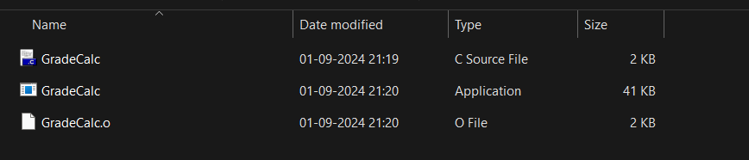

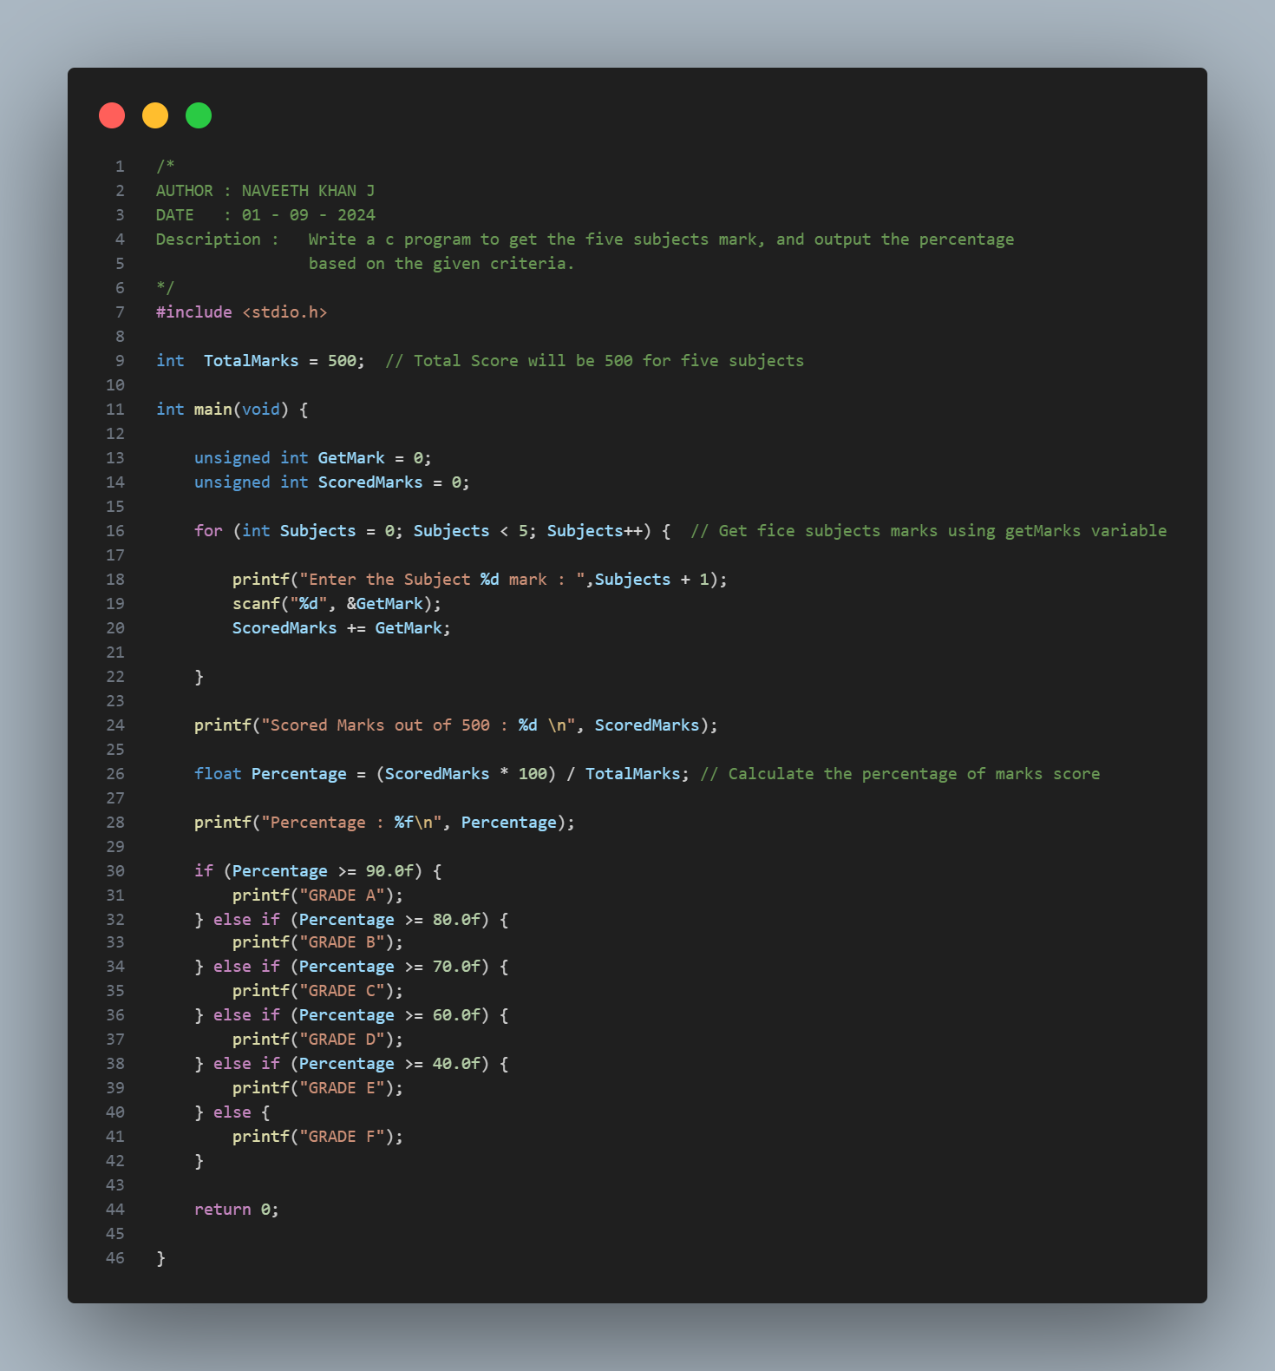

**Output:**

